AI ASSISTED CODING
LAB TEST-3
QUESTION:1
PROMPT: Design and implement a backend API solution for an agriculture company facing challenges in managing crop data, weather integration, and predictive analytics.
Code:
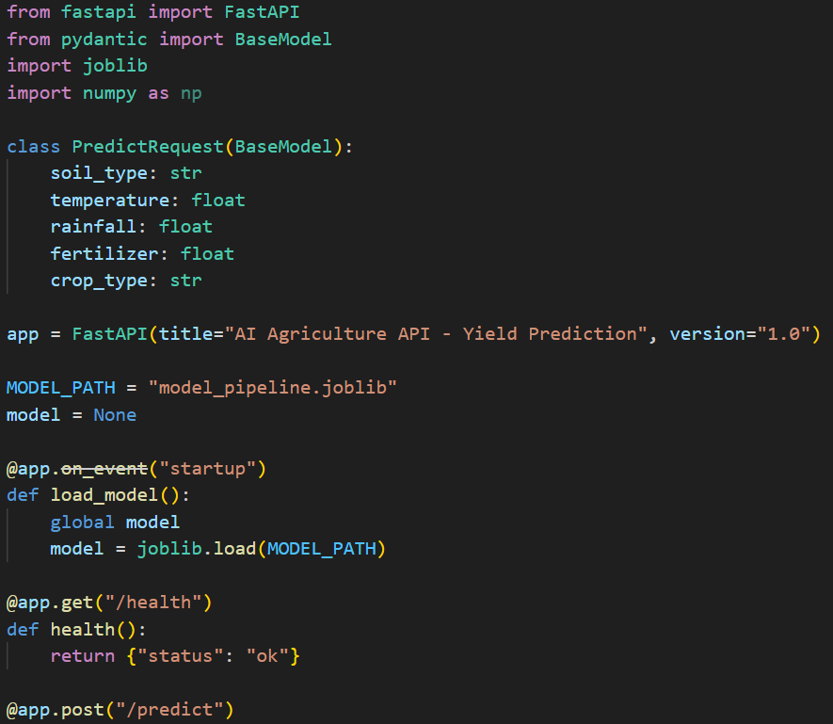
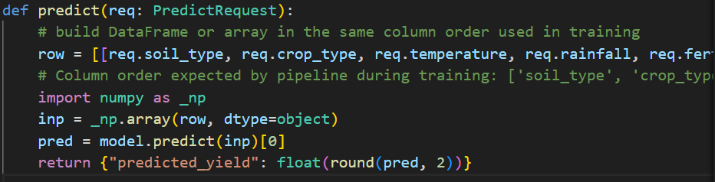
- Explanation: Purpose: REST API endpoint that loads a pre-trained crop yield prediction model and serves predictions.
- Setup: Defines a Pydantic schema (PredictRequest) to validate incoming JSON with soil type, temperature, rainfall, fertilizer, and crop type.
- Startup: Loads the sklearn model from model_pipeline.joblib once when the server starts.
- Health Check: /health endpoint returns {"status": "ok"}.
- Predict: /predict POST endpoint accepts crop data, constructs an input array in the correct column order, calls model.predict(), and returns {"predicted_yield": <float>}.
- Key: Column order must match training data; Pydantic auto-validates inputs.
- Run: uvicorn Q1:app --reload then visit http://127.0.0.1:8000/docs

QUESTION :2
PROMPT: Design and implement a backend solution that uses optimized data structures and AI-assisted tools to solve a challenge in the agriculture domain — predicting yield, or analyzing soil/weather data.
CODE:
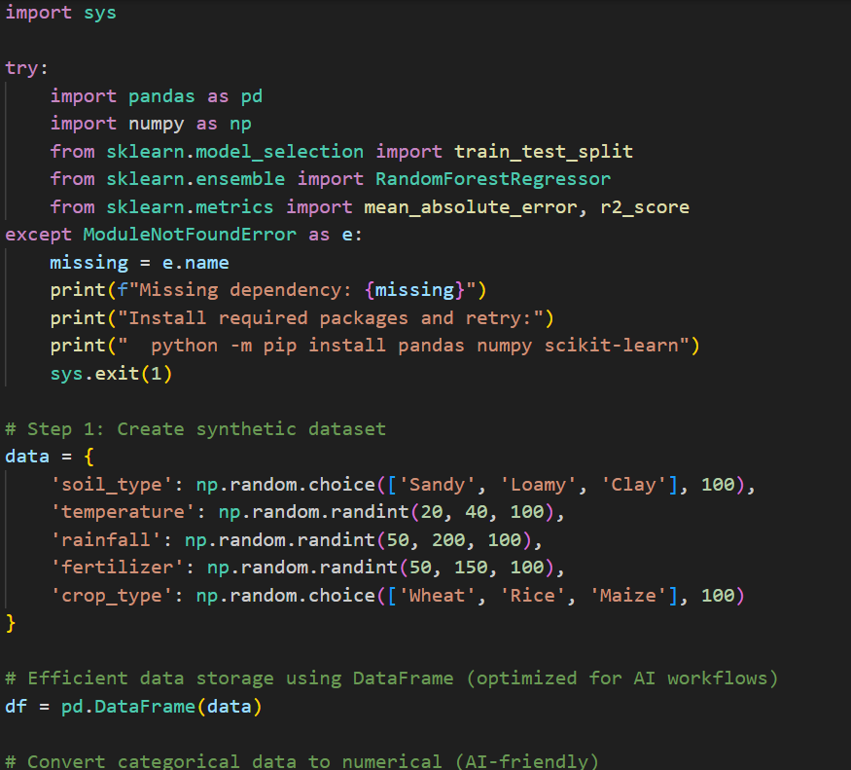
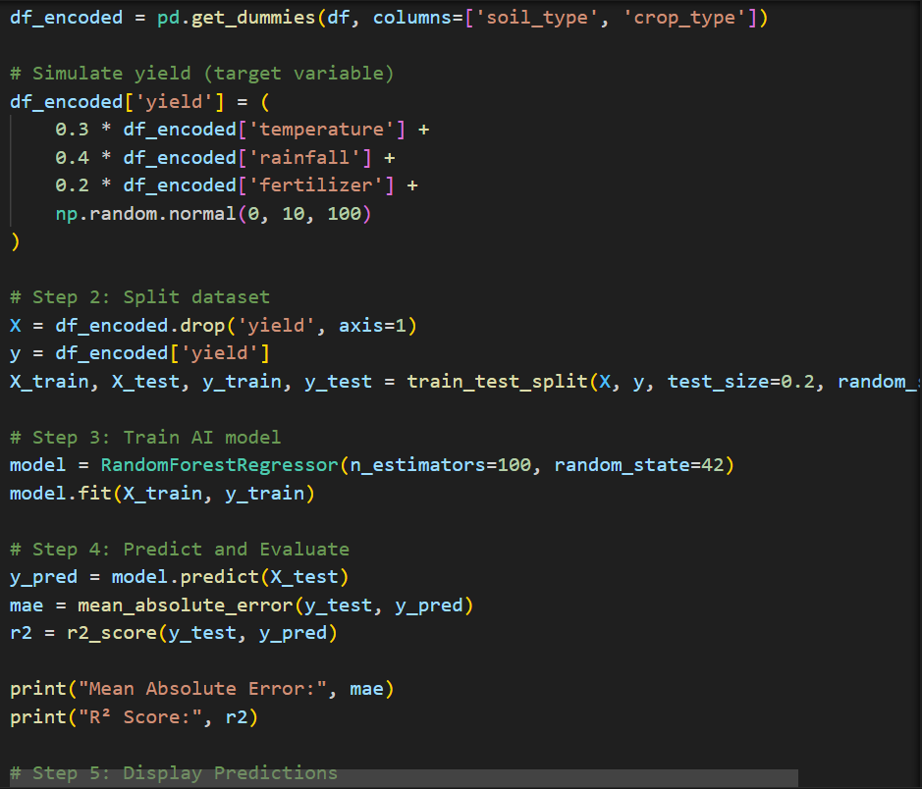
OUTPUT:
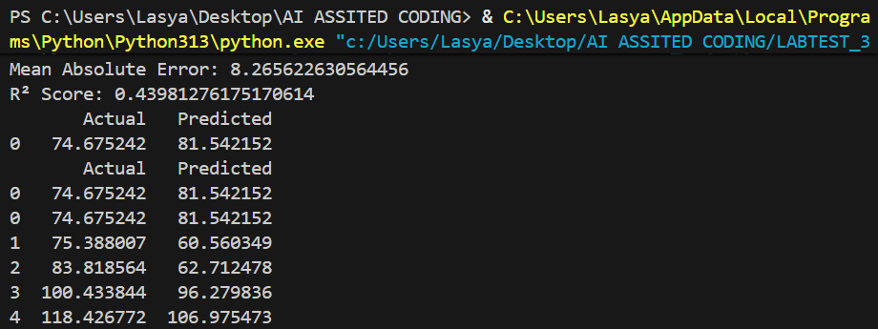
EXPLANATION: The script generates a synthetic crop dataset (soil type, temperature, rainfall, fertilizer, crop type), encodes categorical features, simulates a yield target, splits data into train/test sets, trains a RandomForestRegressor, and prints evaluation metrics (MAE and R²) and a sample of actual vs. predicted values; it also checks for missing dependencies (pandas/numpy/scikit-learn) and instructs how to install them.

